**Critical Thinking Assignment Module Five Assignment**

**User Input Program**

Victor Enogwe

Computer Science, Colorado State University - Global Campus

CSC450-1: Programming III

Reginald Haseltine

May 20, 2024

In this module, we’ve looked at concurrency, its vulnerabilities and file IO mechanisms.

I created a program that reads the content of a file “CSC450_CT5_mod5.txt” into a string, asks the user to enter an input string and appends the user input to the file content. The program also takes the contents of the file “CSC450_CT5_mod5.txt” and reverses it. The reversed content is stored in another file “CSC450_CT5_mod5-reverse.txt” and its content is always overwritten.

**Program Pseudocode**:

PROGRAM: User Input Read/Write Program  
- This program takes a string input from a user and stores it in a file "CSC450_CT5_mod5.txt".  
 The program reverses the values of the contents of the file "CSC450_CT5_mod5.txt" and stores it in "CSC450_CT5_mod5-reverse.txt".  
  
BEGIN  
 BEGIN  
 declare a "read_file" function that takes an absolute file path parameter and returns the content of the file as a string  
 declare a "write_file" function that takes a value(the data to be written), an absolute file path and a file write mode as parameters.  
 The function will write the data to the file in the given mode(append or overwrite).  
 declare a "str_reverse" function that takes a string parameter and returns the reversed string. Make sure the initial string is not mutated.  
 declare a "get_input" function that prompts a user to enter a string and returns the string.  
 The function takes one argument: a string "instruction" to tell the user what to enter.  
 END  
  
 declare a "save_input" function that  
 takes a user's input using the "get_input" function  
 reads the contents of the "CSC450_CT5_mod5.txt" file using the "read_file" function  
 appends the input to the file using the "write_file" function  
 declare a "save_reversed_file_content" function that  
 reads the contents of the "CSC450_CT5_mod5.txt" file using the "read_file" function.  
 reverses the file contents.  
 saves the reversed string to the "CSC450_CT5_mod5-reverse.txt" file using the "write_file" function.  
 the contents of the "CSC450_CT5_mod5-reverse.txt" file should be overwritten.  
 declare a main function to run the program.  
 inside the main function:  
 - call the "save_input" function  
 - call the "save_reversed_file_content" function  
END

**String.h:**

/*  
 * User Input Read/Write Program  
 * String.h  
 * string formatter  
 * Created by Victor Enogwe on 20/05/2024.  
 */  
  
#ifndef STRING_H  
#define STRING_H  
  
#include <string>  
  
using std::string;  
  
string str_trim(const string& value);  
string str_reverse(const string& value);  
  
#endif //STRING_H

**String.cpp:**

/*  
 * User Input Read/Write Program  
 * String.cpp  
 * string formatter  
 * Created by Victor Enogwe on 20/05/2024.  
 */  
  
#include <string>  
#include <regex>  
  
using std::string;  
using std::reverse;  
using std::regex;  
using std::regex_replace;  
  
/*  
 * str_trim  
 * trims the leading and trailing whitespaces in a string  
 * avoids mutating original string  
 *  
 * @Param const string& {value} the original string  
 *  
 * @Return string the trimmed string  
 */  
string str_trim(const string& value) {  
 string s;  
  
 s.assign(value);  
  
 return regex_replace(  
 regex_replace(s, regex( "^\\s+$" ), ""),  
 regex( "\\s+$" ),  
 ""  
 );  
}  
  
/*  
 * str_reverse  
 * reverses a string  
 * avoids mutating original string  
 *  
 * @Param const string& {value} the original string  
 *  
 * @Return string the reversed string  
 */  
string str_reverse(const string& value) {  
 string s;  
  
 s.assign(value);  
  
 reverse(s.begin(), s.end());  
  
 return s;  
}

**File.h:**

/*  
 * User Input Read/Write Program  
 * File.h  
 * reads and writes values to a file  
 * Created by Victor Enogwe on 20/05/2024.  
 */  
  
#ifndef FILE_H  
#define FILE_H  
  
#include <string>  
#include <filesystem>  
  
using std::string;  
using std::filesystem::path;  
using std::filesystem::canonical;  
using std::filesystem::current_path;  
using std::ios;  
  
const path DEFAULT_DIRECTORY = current_path();  
const path FILE_NAME("CSC450_CT5_mod5.txt");  
const path REVERSE_FILE_NAME("CSC450-mod5-reverse.txt");  
const path FILE_PATH = DEFAULT_DIRECTORY / FILE_NAME;  
const path REVERSE_FILE_PATH = DEFAULT_DIRECTORY / REVERSE_FILE_NAME;  
const path FILE_ABSOLUTE_PATH(canonical(FILE_PATH));  
const path REVERSE_FILE_ABSOLUTE_PATH(canonical(REVERSE_FILE_PATH));  
  
string read_file(const path& file_path = FILE_ABSOLUTE_PATH);  
void write_file(const string& value, const path& file_path = FILE_ABSOLUTE_PATH, unsigned int mode = ios::*app*);  
  
#endif //FILE_H

**File.cpp:**

/*  
 * User Input Read/Write Program  
 * File.cpp  
 * reads and writes values to a file  
 * Created by Victor Enogwe on 20/05/2024.  
 */  
  
#include <iostream>  
#include <sstream>  
#include <fstream>  
#include <string>  
#include <filesystem>  
  
using std::cout;  
using std::runtime_error;  
using std::string;  
using std::filesystem::path;  
using std::ifstream;  
using std::ofstream;  
using std::ostringstream;  
using std::ios;  
  
/*  
 * read_file  
 * reads a file from disk  
 *  
 * @Param const path& {file_path} optional the absolute path to the file  
 *  
 * @Return string the file content  
 */  
string read_file(const path& file_path) {  
 try {  
 /*  
 * Reserve string space upfront  
 * and read entire file.  
 * https://stackoverflow.com/a/2602060  
 *  
 * @Note An improvement may be to limit filesize to read  
 * to get the file size the pointer on open can be set to the end of the file  
 * "tellg" call can then be used to check - note that this maybe inacccurate.  
 * https://stackoverflow.com/questions/22984956/tellg-function-give-wrong-size-of-file/22986486#22986486  
 * suggests some remedies to using "tellg" for file size check.  
 */  
  
 cout << "Reading file(" << file_path << ") from disk\n";  
  
 ifstream input_file(file_path);  
 ostringstream buffer;  
  
 buffer << input_file.rdbuf();  
  
 const string value = buffer.str();  
  
 input_file.close();  
  
 return value;  
 } catch (const runtime_error& error) {  
 cout << "Error reading file(" << file_path << ") from disk\n";  
  
 throw error;  
 }  
}  
  
/*  
 * write_file  
 * appends string content to a file on disk  
 *  
 * @Param const string& {value} the data to write  
 * @Param const path& {file_path} optional the absolute path to the file  
 *  
 * @Returns void  
 */  
void write_file(const string& value, const path& file_path, const unsigned int mode) {  
 try {  
 cout << "Writing value to file(" << file_path << ") on disk\n";  
  
 // open file - create if not exists  
 ofstream output_file;  
  
 output_file.open(file_path, mode);  
  
 output_file << value;  
  
 output_file.close();  
 } catch (const runtime_error& error) {  
 cout << "Error writing to file(" << file_path << ") on disk\n";  
  
 throw error;  
 }  
}

**Input.h:**

/*  
 * User Input Read/Write Program  
 * Input.h  
 * reads and formats user input  
 * Created by Victor Enogwe on 20/05/2024.  
 */  
  
#ifndef INPUT_H  
#define INPUT_H  
  
#include <string>  
  
using std::string;  
  
string get_input(const string& instruction);  
  
#endif //INPUT_H

**Input.cpp:**

/*  
 * User Input Read/Write Program  
 * Input.cpp  
 * reads and formats user input  
 * Created by Victor Enogwe on 20/05/2024.  
 */  
  
#include <iostream>  
#include <string>  
#include <regex>  
#include "String.h"  
  
using namespace std::regex_constants;  
  
using std::cout;  
using std::cin;  
using std::getline;  
using std::string;  
using std::regex;  
using std::regex_replace;  
using std::regex_match;  
using std::runtime_error;  
using std::stoi;  
  
/*  
 * get_input  
 * asks a user to enter an integer  
 *  
 * @Param const string& {instruction} user instruction  
 *  
 * @Return string the input string  
 */  
string get_input(const string& instruction) {  
 try {  
 cout << instruction;  
  
 string input;  
  
 getline(cin, input);  
  
 return input;  
 } catch (const runtime_error& error) {  
 cout << error.what();  
  
 throw error;  
 }  
}

**Main.cpp:**

#include <iostream>  
/*  
 * Program: User Input Read/Write Program  
 * a program that will take a string input from a user and store it in a file "CSC450_CT5_mod5.txt".  
 * The program reverses the values of the contents of the file "CSC450_CT5_mod5.txt" and stores it in "CSC450_CT5_mod5-reverse.txt".  
 */  
  
#include <fstream>  
#include <string>  
#include <filesystem>  
  
#include "File.h"  
#include "Input.h"  
#include "String.h"  
  
using std::cout;  
using std::runtime_error;  
using std::string;  
using std::filesystem::path;  
using std::filesystem::canonical;  
using std::filesystem::current_path;  
using std::ifstream;  
using std::ofstream;  
using std::ios;  
using std::istreambuf_iterator;  
  
void save_input() {  
 cout << "**Writing User Input to File**\n";  
  
 const string file_contents = read_file();  
 const string input = get_input("Enter some text to append to the file: ");  
  
 write_file(input);  
  
 cout << "\n";  
}  
  
void save_reversed_file_content() {  
 cout << "**Writing Reversed File Content to File**\n";  
  
 const string file_contents = read_file();  
 const string reversed_file_content = str_reverse(file_contents);  
  
 write_file(reversed_file_content, REVERSE_FILE_ABSOLUTE_PATH, ios::*trunc*);  
  
 cout << "\n";  
}  
  
int main() {  
 cout << "**User Input Read/Write Program**\n\n";  
  
 save_input();  
 save_reversed_file_content();  
  
 return 0;  
}

**Git Repository Image: Git Branch = Main** **- [https://github.com/victor-csu/](https://github.com/victor-csu/CSC450-Module-Three-Critical-Thinking/tree/main)****[CSC450-Module-Three-Critical-Thinking/tree/main](https://github.com/victor-csu/CSC450-Module-Three-Critical-Thinking/tree/main)**

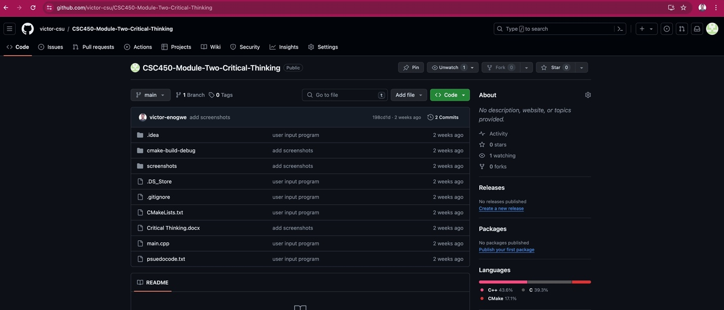

**Happy Path Execution Screenshot – Fictional Person - CSC450_CT3_mod3-0-execution-output:**

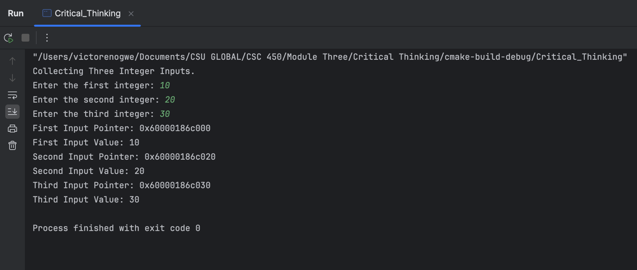

References